Batch: C3 Roll No.: 16010123217

Experiment No. : 3

Grade: AA / AB / BB / BC / CC / CD /DD

Signature of the Staff In-charge with date

Title: Study, Implementation, and Comparative Analysis of Merge Sort and Quick Sort.

Objective: To learn the divide and conquer strategy of solving the problems of different types

CO to be achieved:
CO 2 | Describe various algorithm design strategies to solve different problems and analyze Complexity.

Books/ Journals/ Websites referred:
- Ellis horowitz, Sarataj Sahni, S.Rajsekaran,” Fundamentals of computer algorithm”, University Press
- T.H.Cormen ,C.E.Leiserson,R.L.Rivest and C.Stein,” Introduction to algortihtms”,2nd Edition ,MIT press/McGraw Hill,2001
- http://en.wikipedia.org/wiki/Quicksort
- https://www.cs.auckland.ac.nz/~jmor159/PLDS210/qsort.html
- http://www.cs.rochester.edu/~gildea/csc282/slides/C07-quicksort.pdf
- http://www.sorting-algorithms.com/quick-sort
- http://www.cse.ust.hk/~dekai/271/notes/L01a/quickSort.pdf
- http://en.wikipedia.org/wiki/Merge_sort
- http://www.personal.kent.edu/~rmuhamma/Algorithms/MyAlgorithms/Sorting/mergeSort.htm
- http://www.sorting-algorithms.com/merge-sort
- http://www.princeton.edu/~achaney/tmve/wiki100k/docs/Merge_sort.html

Pre Lab/ Prior Concepts:
Data structures, various sorting techniques

Historical Profile:
Quicksort and merge sort are divide-and-conquer sorting algorithm in which division is dynamically carried out. They are one the most efficient sorting algorithms.

New Concepts to be learned:
Number of comparisons, Application of algorithmic design strategy to any problem, Classical problem solving vs Divide-and-Conquer problem solving.

Algorithm Recursive Quick Sort:
void quicksort( Integer A[ ], Integer left, Integer right)
//sorts A[left.. right] by using partition() to partition A[left.. right], and then //calling itself // twice to sort the two subarrays.
{ IF ( left < right ) then
{ q = partition( A, left, right);
quicksort( A, left, q–1);
quicksort( A, q+1, right);
}
}

Integer partition(integer AT[], Integer left, Integer right)
//This function rarranges A[left..right] and finds and returns an integer q, such that A[left], ..., //A[q–1] <∼ pivot, A[q] = pivot, A[q+1], ..., A[right] > pivot, where pivot is the first element of //a[left…right], before partitioning.
{
pivot = A[left]; lo = left+1; hi = right;
WHILE ( lo ≤ hi)
{ WHILE (A[hi] > pivot) hi = hi – 1;
WHILE ( lo ≤ hi and A[lo] <∼pivot) lo = lo + 1;
IF ( lo ≤ hi) then swap( A[lo], A[hi]);
}
swap(pivot, A[hi]);
RETURN hi;
}

Code (Quick Sort) :

#include <bits/stdc++.h>
using namespace std;
#define int long long
#define endl "\n"

const int MOD = 1e9 + 7;
const int INF = LLONG_MAX >> 1;

void quicksort(vector<int> &arr, int bigger, int smaller) {
if (bigger >= smaller) return;

int pivot = arr[bigger];
int i = bigger + 1, j = smaller;

while (i <= j) {
while (i <= j && arr[i] <= pivot) i++;
while (i <= j && arr[j] > pivot) j--;
if (i < j) {
swap(arr[i], arr[j]);
}
}
swap(arr[bigger], arr[j]);

quicksort(arr, bigger, j - 1);
quicksort(arr, j + 1, smaller);
}

signed main() {
ios::sync_with_stdio(false); cin.tie(NULL);

int n;
cin >> n;
vector<int> arr(n);
for (int i = 0; i < n; i++) cin >> arr[i];

quicksort(arr, 0, n - 1);

for (int i = 0; i < n; i++) cout << arr[i] << " ";
return 0;
}

Output:
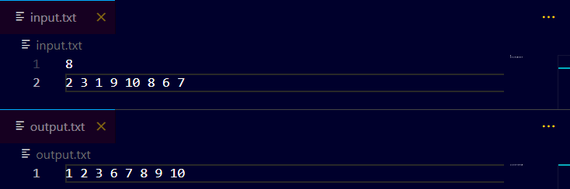

The space complexity of Quick Sort:
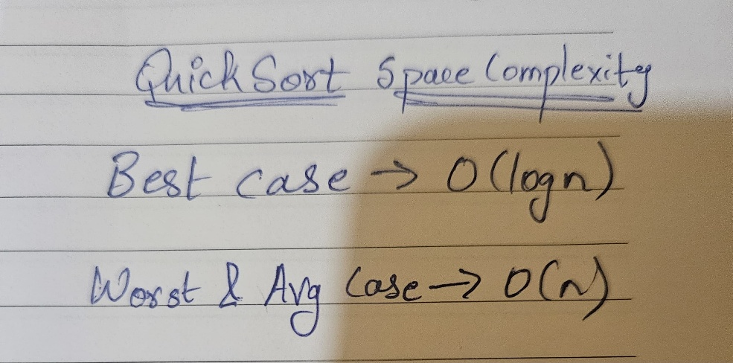
Derivation of best case and worst-case time complexity (Quick Sort)
Algorithm Merge Sort
MERGE-SORT (A, p, r)
// To sort the entire sequence A[1 .. n], make the initial call to the procedure MERGE-SORT (A, //1, n). Array A and indices p, q, r such that p ≤ q ≤ r and sub array A[p .. q] is sorted and sub array //A[q + 1 .. r] is sorted. By restrictions on p, q, r, neither sub array is empty.
//OUTPUT: The two sub arrays are merged into a single sorted sub array in A[p .. r].
IF p < r // Check for base case
THEN q = FLOOR [(p + r)/2] // Divide step
MERGE (A, p, q) // Conquer step.
MERGE (A, q + 1, r) // Conquer step.
MERGE (A, p, q, r) // Conquer step.

MERGE (A, p, q, r)
{
n₁ ← q − p + 1
n₂ ← r − q
Create arrays L[1 . . n₁ + 1] and R[1 . . n₂ + 1]
FOR i ← 1 TO n₁
DO L[i] ← A[p + i − 1]
FOR j ← 1 TO n₂
DO R[j] ← A[q + j ]
L[n₁ + 1] ← ∞
R[n₂ + 1] ← ∞
i ← 1
j ← 1
FOR k ← p TO r
DO IF L[i ] ≤ R[ j]
THEN A[k] ← L[i]
i ← i + 1
ELSE A[k] ← R[j]
j ← j + 1

}

Code (MergeSort) :
#include <bits/stdc++.h>
using namespace std;
#define int long long
#define endl "\n"

const int MOD = 1e9 + 7;
const int INF = LLONG_MAX >> 1;

void mergesort(vector<int> &arr, int start, int end ){
if(start >= end) return;
int mid = start + (end - start) / 2;
mergesort(arr, start, mid);
mergesort(arr, mid+1, end);
vector<int> temp(end-start+1);
int i = start, j = mid+1, k = 0;
while(i <= mid && j <= end){
if(arr[i] < arr[j]) temp[k++] = arr[i++];
else temp[k++] = arr[j++];
}
while(i <= mid) temp[k++] = arr[i++];
while(j <= end) temp[k++] = arr[j++];
for(int i = start; i <= end; i++) arr[i] = temp[i-start];
}

signed main(){
ios::sync_with_stdio(false); cin.tie(NULL);

int n; cin >> n;
vector<int> v(n);
for (int i = 0; i < n; i++) cin >> v[i];
mergesort(v, 0, n-1);
for(int i = 0; i < n; i++) cout << v[i] << " ";
return 0;
}

Output:
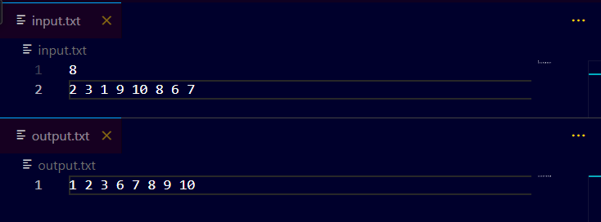
The space complexity of Merge sort:
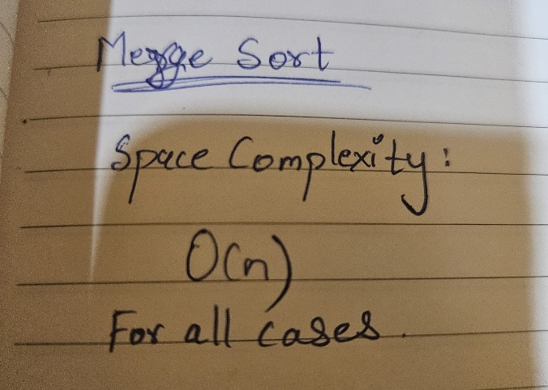
Derivation of best case and worst-case time complexity (Merge Sort)
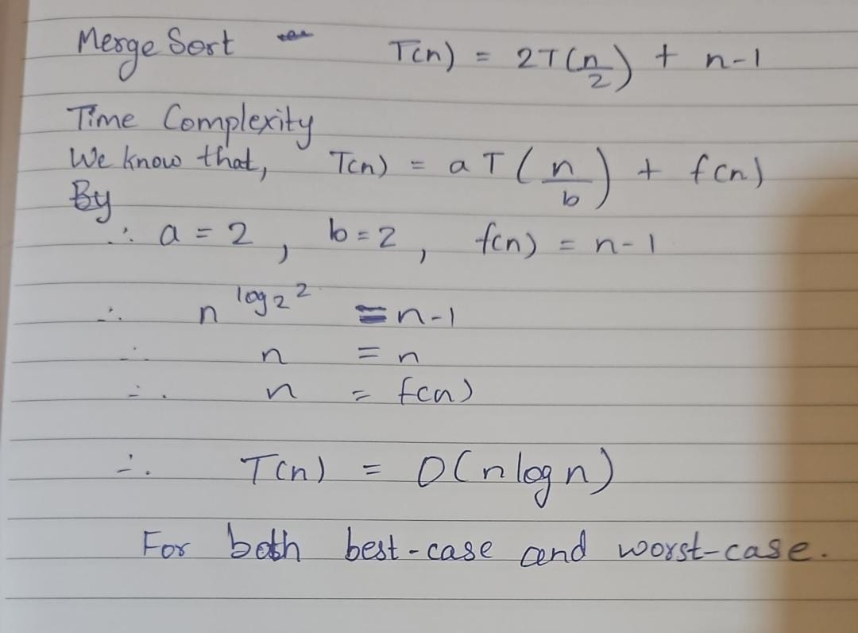
Example for quicksort/Merge tree for merge sort:
Merge Sort
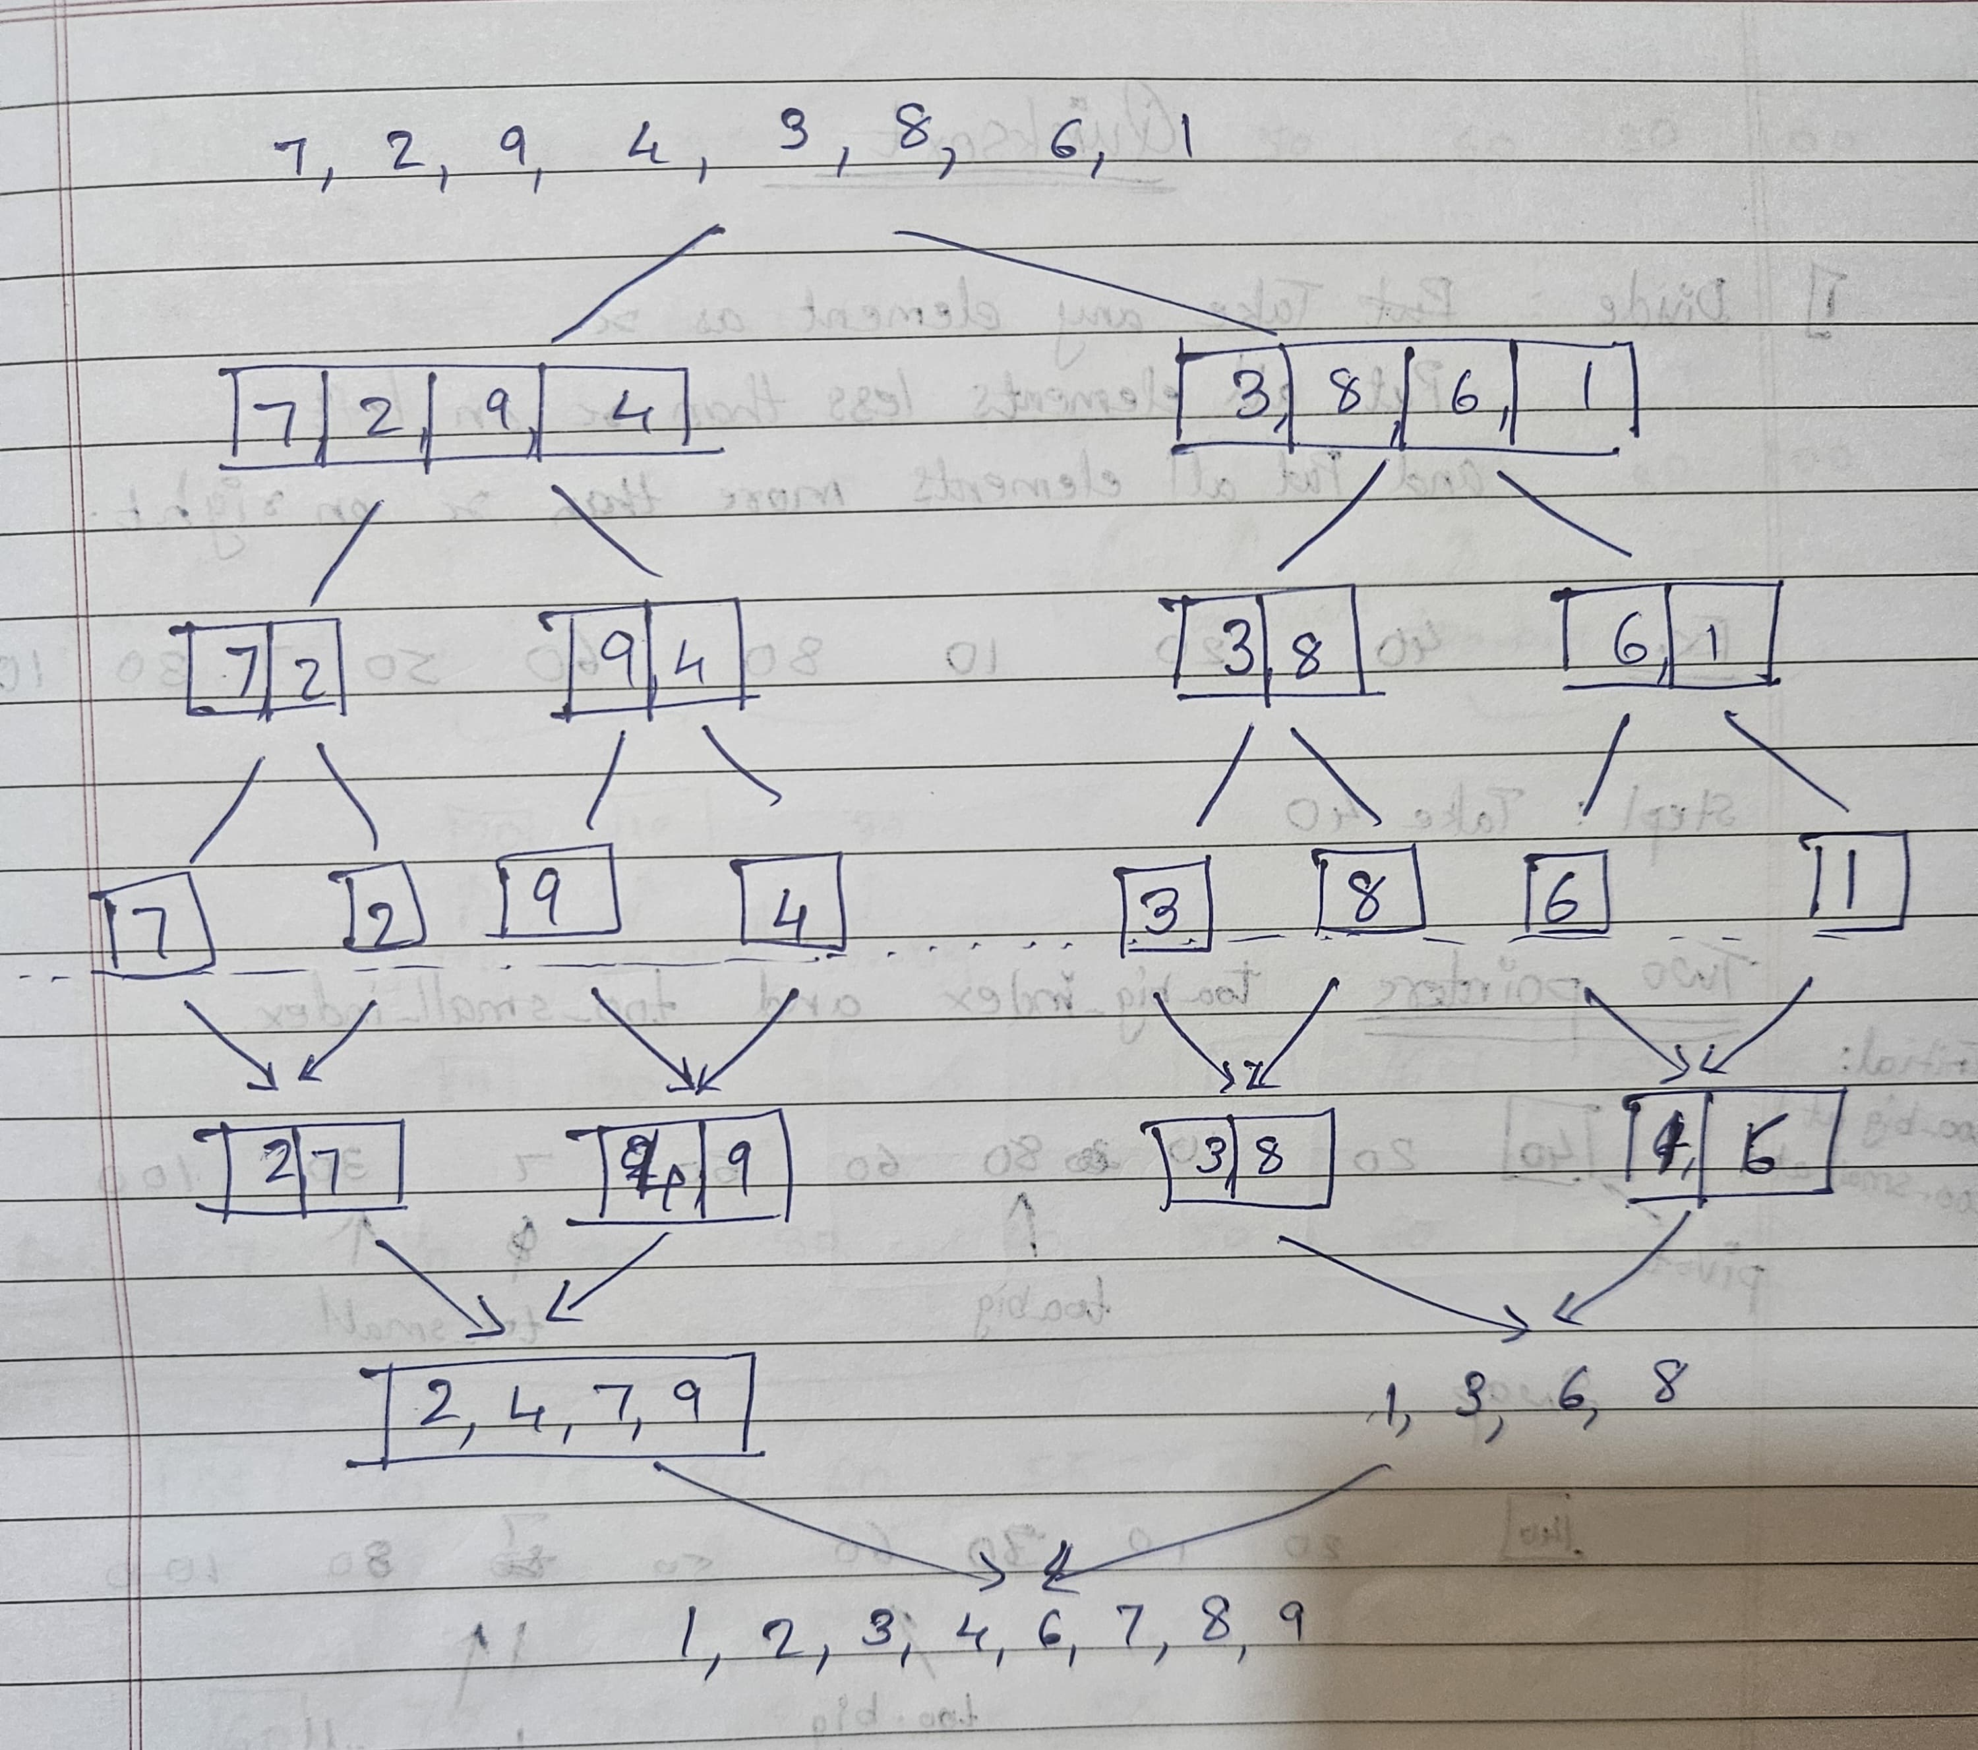

Quick Sort
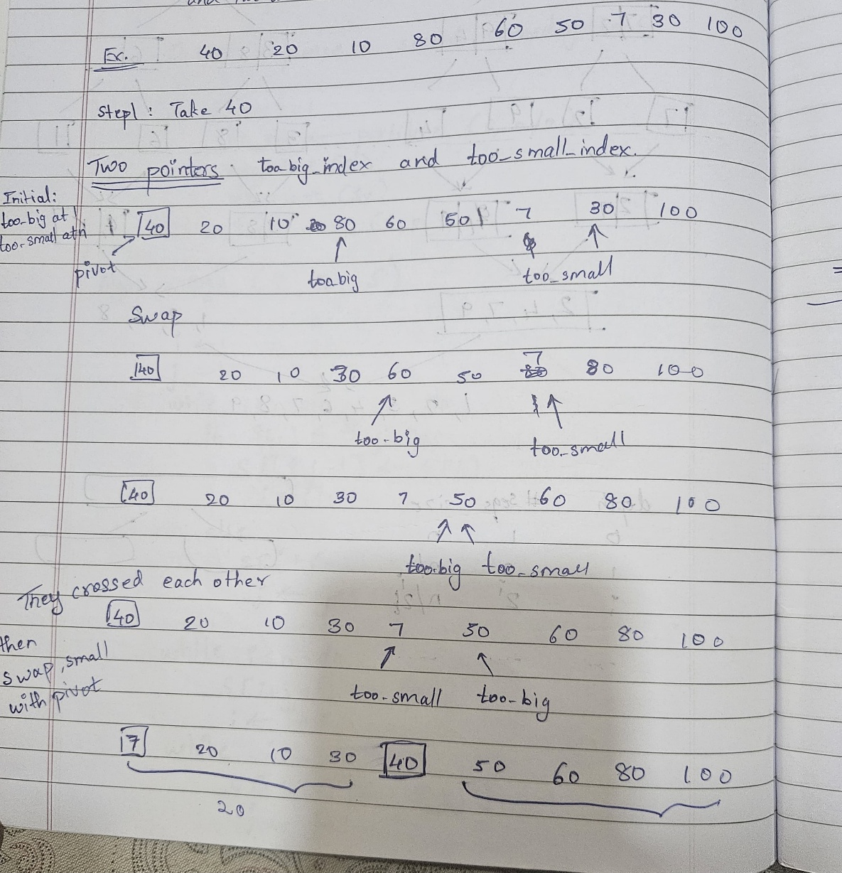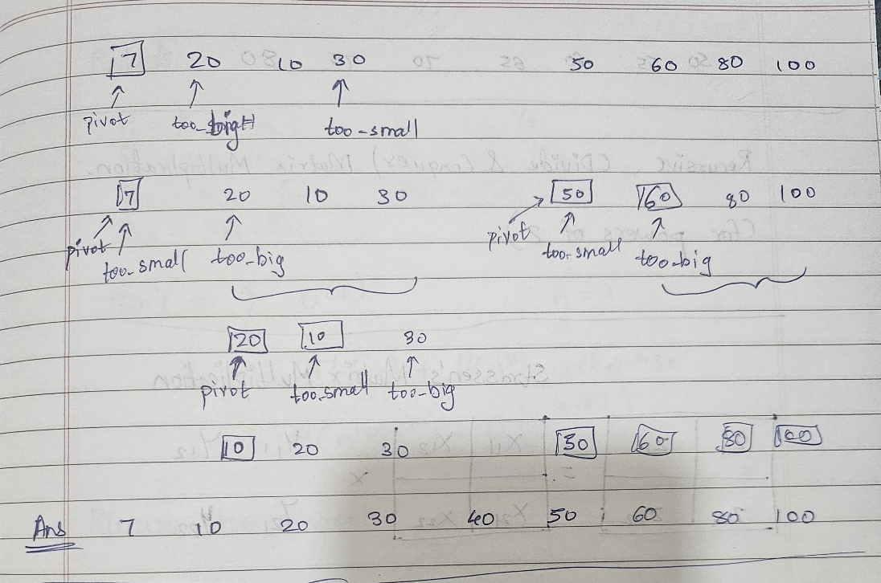

CONCLUSION:

We learnt about sorting algorithms like merge sort and quick sort and their time and space complexities

